MILESTONE 1  
EXCEL & SQL  
  
KISHORE VASUDEVAN  
11/04/2025  
DATA ANALYTICS & DATA SCIENCE  
FEB 25’

PROJECT OVERVIEW:

The dataset represents a salary survey of individuals across various industries and job roles. It includes details such as age range, country, state, city, gender, and education level. The dataset contains approximately **28,103 records**, providing a comprehensive view of global compensation trends.

OBJECTIVE:

Analyze global salary trends across demographics, industries, roles, and education levels.

TOOLS USED:

* Excel
* SQL

DATA CLEANING & PREPARATION:

* Removed duplicate entries using the **“Remove Duplicates”** feature (151 Records).
* Performed spell checks across all columns and corrected errors.
* Standardized city names using the “**Geography”** data type in Excel.
* Grouped gender values into: **Male, Female, Non-Binary, Others**.
* Converted all salary values to **USD** based on exchange rates by country.
* Identified outliers using the **quartile (IQR) method**. Retained them, as even $1 can be a valid salary.
* After cleaning, we have a total of **26,719** records.
* Executed data analysis using **SQL queries** for insights.

SQL IMPORT:

* After cleaning, the entire dataset needs to be imported into SQL.
* Create a database named Salary_Survey.
* Create a table named Salary_data.
* After creating the table, right-click on it and select '**Table Data Import Wizard**’ to import data.
* In the wizard, fill in the respective columns and click **'Next**' to import the data.
* The screenshot below shows that **26,719** records have been successfully imported.

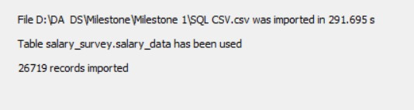

SQL QUERIES:

1. Average Salary by Industry and Gender:

select Industry,Gender,Concat("$ ",round(avg(Salary_USD),2)) as Average_Salary

from salary_data

group by Industry,Gender;

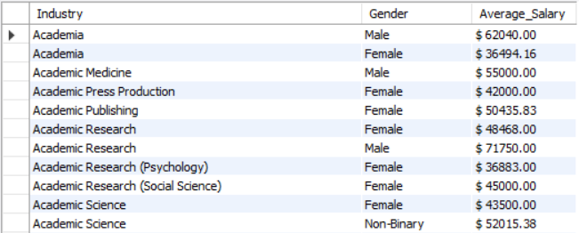

The chart above displays only the top 5 industries due to the large number of industry titles. From the chart, we can observe that the Entertainment industry performed the best, with a total salary sum of $732,714.23. Within this industry, Non-Binary individuals earned the highest salary, amounting to $436,082.90. The second-best performing industry was Computing & Tech, with a total of $487,439.56, where males earned the highest salary at $131,675.82. The industry with the lowest total salary among the top 5 was Environmental Regulation.

1. Total Salary Compensation by Job Title:

select Job_Title, sum(Salary_USD), sum(Additional_Monetary_Compensation_USD),

concat("$ ",sum(Salary_USD + Additional_Monetary_Compensation_USD)) as Total_Salary

from salary_data group by Job_Title;

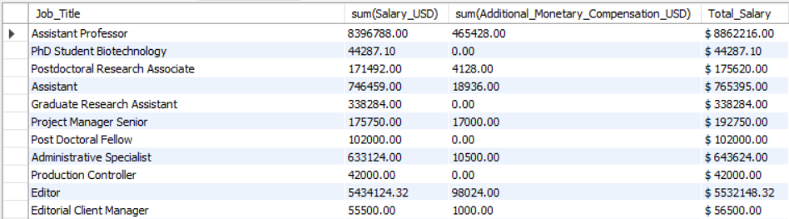

The chart above shows the top 5 total salaries by job title. "Software Engineer" holds the highest total salary, amounting to $60,604,653.64, followed by "Senior Software Engineer" with $46,701,186.34. The lowest is "BI Consultant."

1. Salary Distribution by Education Level :

select Education,concat("$ ",round(avg(Salary_USD),2)) as Average_Salary,

concat("$ ",min(Salary_USD)) as Minimum_Salary,

concat("$ ",max(Salary_USD)) as Maximum_Salary

from salary_data group by Education;

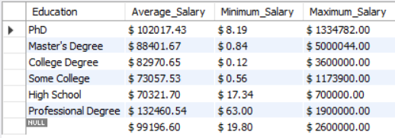

The chart above displays a combination of minimum, maximum, and average salaries by education level. It shows that a Master's degree corresponds to the highest maximum salary, amounting to $5,000,044. The highest average salary is associated with a Professional degree at $132,460.54. Interestingly, the lowest minimum salary also falls under the Professional degree category, at just $63.00.

1. Number of Employees by Industry and Years of Experience:

select count(Industry) as No_Of_Employees,Industry,Years_of_Professional_Experience_Overall

from salary_data

group by Industry,Years_of_Professional_Experience_Overall;

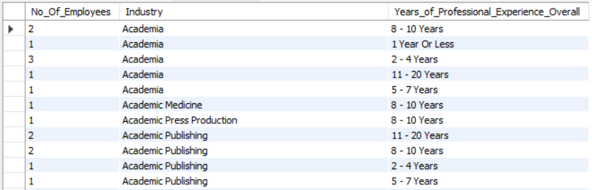

The chart above highlights the top 5 industries based on the number of employees, categorized by relevant years of experience. The Computing & Tech industry has the highest total number of employees, with 4,533 individuals. Most of them fall within the 11–20 years experience range (1,556), followed by those with 8–10 years (829). The Non-Profit industry comes next, with a total of 2,304 employees, mainly in the 11–20 years range (848), followed by 8–10 years (495). The Ecology industry has the lowest number of employees.

1. Median Salary by Age Range and Gender :

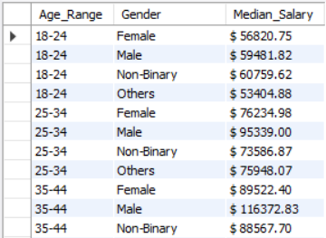select Age_Range,Gender,

concat("$ ",round(avg(Salary_USD),2)) as Median_Salary

from salary_data

group by Age_Range,Gender

order by Age_Range asc;

The chart above presents the median salary based on gender and age range. Overall, Non-Binary individuals had the highest total salary, amounting to $671,657.67. Within this group, the highest salary came from the under-18 age range, totaling $239,946.60, followed by the 35–44 age range with $88,567.70. Males also showed strong performance, with a total salary sum of $611,401.65.

1. Job Titles with the Highest Salary in Each Country:

select Job_Title,Country,concat("$ ",max(Salary_USD)) as Maximum_Salary

from salary_data

group by Job_Title,Country order by Maximum_Salary desc;

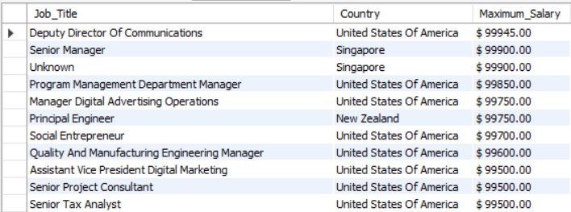

The chart displays only the top 5 job titles and top 5 countries due to the large volume of data. Among them, the highest salary is for the role of Inside Sales Manager in the USA, with a salary of $5,000,044.00. This is followed by the Japanese to English Translator role, also in the USA, with a maximum salary of $3,600,000.00.

1. Average Salary by City and Industry :

select Industry,City,concat("$ ",round(avg(Salary_USD),2)) as Average_Salary

from salary_data

group by Industry,City;

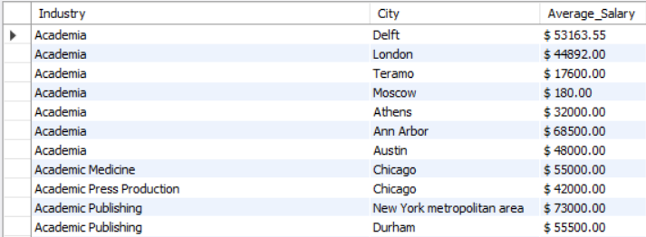

The chart displays the average salary by city and industry, focusing on the top 5 cities and top 5 industries. Overall, New Haven ranks first, where the Healthcare industry offers the highest average salary of $985,000.00, followed by Computing & Tech at $127,066.67. In Princeton, the highest average salary is in Government & Public Administration at $672,000.00, followed by Healthcare at $116,333.33.

1. Percentage of Employees with Additional Monetary Compensation by Gender:

select Gender,

concat(round(100 * sum(

case when

Additional_Monetary_Compensation > 0

then 1

else 0

end) / count(*), 2),'%') as Additional_Monetary_Compensation

from salary_data

group by Gender

order by Gender;

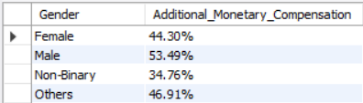

From the above chart, we can see the percentage of additional compensation received by each gender. Males receive the highest at 53.49%, followed by Others at 46.91%, Females at 44.30%, and Non-Binary individuals at 34.76%. This clearly indicates that males receive the highest percentage of additional compensation.

1. Total Compensation by Job Title and Years of Experience:

select Job_Title,Years_of_Professional_Experience_in_Field,

concat("$ ",sum(Salary_USD+Additional_Monetary_Compensation_USD)) as Total_Salary

from salary_data

group by Job_Title,Years_of_Professional_Experience_in_Field;

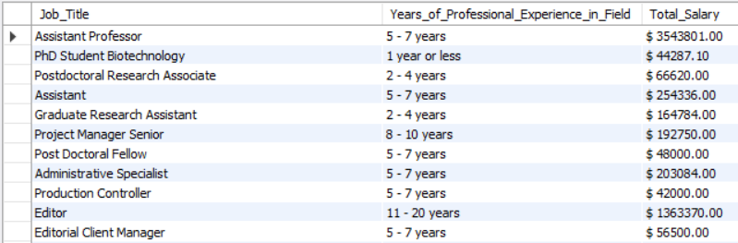

From the above chart, we can understand that **Software Engineers** receive the highest total compensation, with a sum of **$6,064,653.64**. Among them, those with **2–4 years of experience** earn the most, totaling **$1,930,713.90**, followed by those with **11–20 years of experience**, earning **$7,887,782.50**. This is followed by **Senior Software Engineers**, with a total compensation of **$4,670,186.34**.

1. Average Salary by Industry, Gender, and Education Level:

select Industry,Gender,Education, concat("$ ",round(avg(Salary_USD),2)) as Average_Salary

from salary_data

group by Industry,Gender,Education;

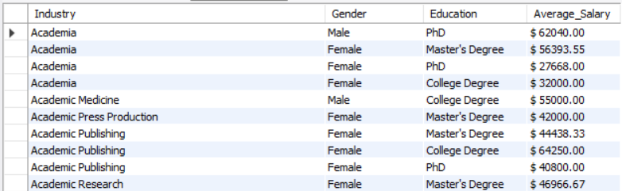

From the two charts, we can compare average salaries across gender, education, and industry. **College degrees** represent the highest-paying education pathway, with a total salary sum of **$43,193,483.74**. Within this group, the **Computing or Tech** industry stands out with a salary sum of **$3,225,524.95**, where **males** contribute the most with **$1,030,799.29**.

Following that, **Master’s degrees** account for a total salary sum of **$38,949,747.50**, with the **Healthcare** industry performing the best, contributing **$2,421,794.80** in total salary.

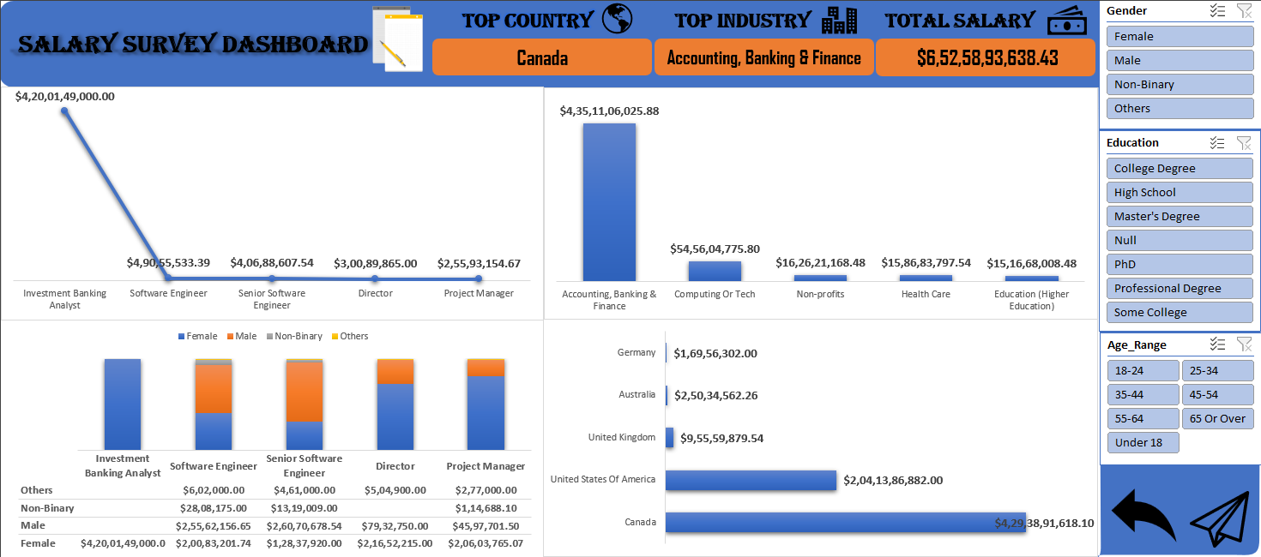DASHBOARD:

INSIGHTS:

* + **Software Engineers** and **Senior Software Engineers** dominate total compensation across all job titles.
  + The **Computing & Tech** industry is both the highest-paying and the largest in terms of workforce.
  + **Males** are the most likely to receive additional compensation such as bonus.
  + **Non-Binary individuals**, while fewer in number, receive some of the **highest base salaries**, especially in younger age groups.
  + **College degrees** are the most common and yield the **highest total compensation**, especially in tech.
  + **Professional degrees** offer the highest **average salary** but come with significant variation.
  + **Healthcare and Tech** are the top-performing industries for those with Master's and College degrees respectively.
  + Smaller academic or healthcare-dense cities (e.g., **New Haven**, **Princeton**) often show the highest average salaries.
  + The **USA** leads globally in maximum salaries across multiple roles.
  + Experience levels of **2–4 years** and **11–20 years** appear to be the most financially rewarding ranges.

FINDINGS:

* + The highest total salary observed was for a **Software Engineer**, totalling **$60.6M**.
  + The **Entertainment** industry paid the most to **Non-Binary individuals**, totalling **$436K**.
  + **Inside Sales Manager** in the USA had the highest single salary entry at **$5M**.
  + The **Computing & Tech** industry employed the largest number of professionals (4,533), especially those with **11–20 years** of experience.
  + The **highest maximum salary** by education was seen under a **Master’s degree** ($5M), while the **highest average** was for a **Professional degree** ($132K).
  + **New Haven’s Healthcare sector** paid an average of **$985K**, the highest average by city-industry combo.
  + **Males** received **53.49%** of the total additional compensation distribution.
  + **College degree holders** contributed to a total salary pool of **$43.19M**, with **$3.22M** coming from the Computing & Tech industry alone.
  + **2–4 years of experience** among Software Engineers earned **$1.93M** in total, a standout among early-career roles.
  + Despite fewer entries, **Non-Binary individuals** under 18 earned as much as **$239K**, an exceptional outlier.

CONCLUSION:

This analysis provided a comprehensive view of global salary trends across various demographics, roles, industries, and education levels.

Key findings reveal that the Computing & Tech industry consistently offers high compensation and employment opportunities, while education level and years of experience significantly influence earning potential.

Gender-based disparities exist in additional compensation, yet notable high earners emerge across all gender categories.

Overall, the insights derived from this dataset can guide career planning, compensation benchmarking, and industry-level talent strategies.